KKRV -

Functionality
To select data for a drilldown report, you must first execute a data collection run. The selected dataset is saved. You access this saved dataset when you execute the report.
You can execute the data collection for one plant or for all plants in a controlling area.

You can also select the summarization time frame. The values in the summarization time frame are re-summarized and any old values are overwritten. Summarized values that are outside of the summarization time frame are retained.
This step should be done before you execute the product drilldown report.

Scenario
Execute the report to select data for product drilldown in plant 1200 in period 12 of the year 2002.

Requirements
Data were posted to cost objects (related to period and order related scenario) in Product Cost Controlling.

Menu Path | Accounting → Controlling → Product Cost Controlling → Cost Object Controlling → Product Cost by Order → Information System → Tools → Data Collection → KKRV – For Product Drilldown
Transaction Code | KKRV

1. Double click on the KKRV – For Product Drilldown.
Data Collection for Product Drilldown

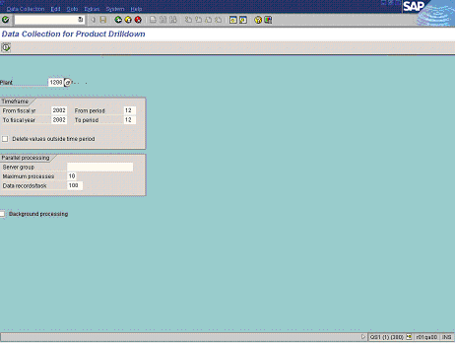

2. Update the following fields:

Field Name | Field Description | Values
Plant | Code identifying the operational unit of the company where the material is manufactured and stored. | Example: 1200
From fiscal yr | The fiscal year you start to collect data for. | Example: 2002
From period | The period you start to collect data for. | Example: 12
To fiscal year | The fiscal year you finish to collect data for | Example: 2002
To period | The period you finish to collect data for. | Example: 12

3. Click the Background processing checkbox to deselect.

Note: Deselect the Background processing to run the data collection online.

4. Click the Execute button.

Data Collection for Multidimensional Product Cost Controlling

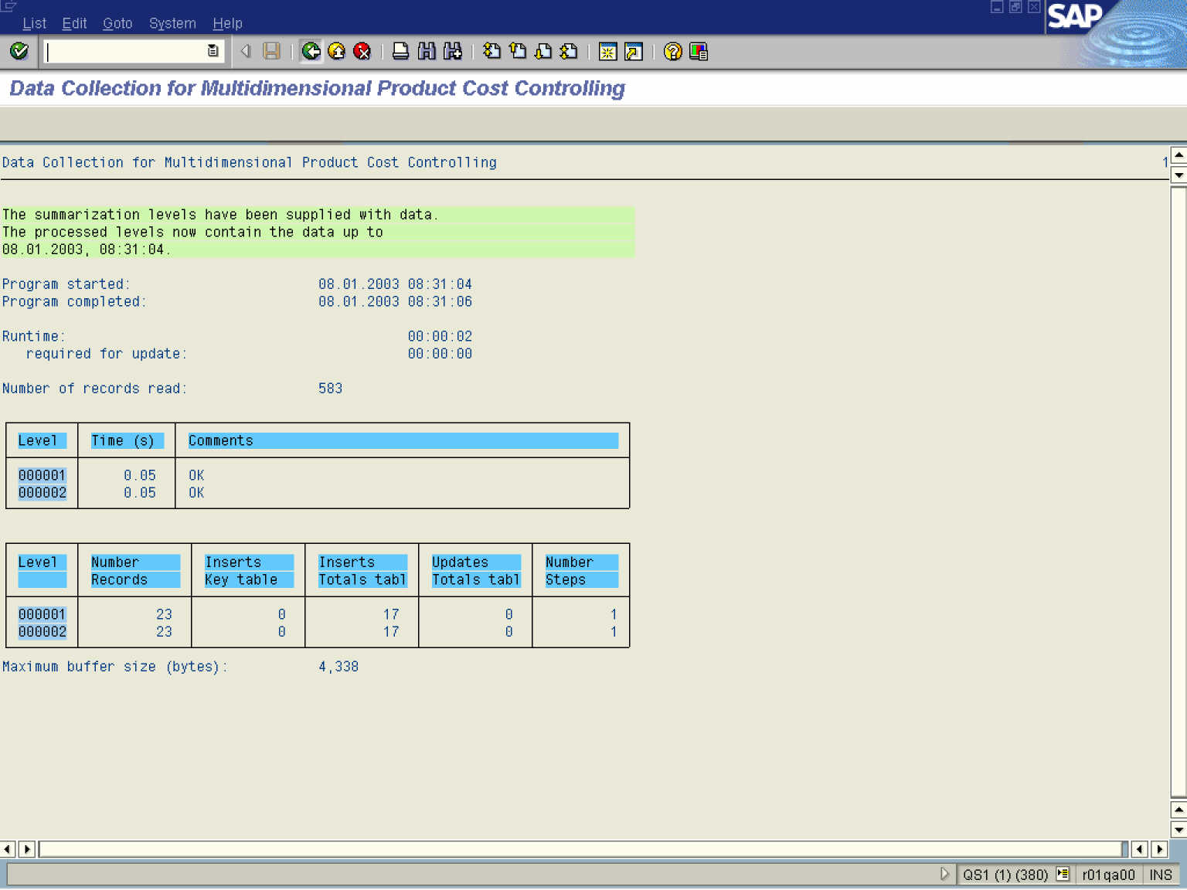

5. Click the Back button.

